A university teaching and research-active Trust
Bridge Park Plaza
Bridge Park Road
Thurmaston Leicester
LE4 8PQ

www.leicspart.nhs.uk
August 2020
Dear Parent / Carer,
Childhood seasonal flu vaccination programme
As part of the national vaccination programme, Leicestershire Partnership NHS Trust’s Community Immunisation Service would like to offer you the opportunity to protect your child against seasonal flu (influenza) this winter.
The flu vaccination programme is a high priority within public health policy every year. However, in light of the risk of flu and Covid-19 co-circulating this winter, the national flu immunisation programme will be absolutely essential to protecting vulnerable people and supporting the resilience of the health and care system. This offer for flu vaccinations has been extended to include young people in school year 7 in secondary schools.
Children from reception year to year 7 (born between 1st September 2008 and 31st August 2016) will be offered the nasal flu vaccination in school. Younger children aged 2 and 3 years will be offered the flu vaccination at their GP surgery.

Alternative flu injection
We recognise that gelatine used in the manufacture of the nasal flu vaccine is not preferrable for some parents, therefore, in this flu season, we are also offering a gelatinefree injection instead. When making a decision to opt for this, please bear in mind that the gelatine-free injection:
- is less effective than the nasal flu;
- an injection into the muscle could be uncomfortable, therefore we may not be able to give it without your presence;
- it will be available later in the flu season and then only if sufficient vaccine stocks are available and so there is likely to be a significant delay in receiving it.
Please see box below for instructions on how to opt for the flu injection.
To read the patient information leaflet about the flu vaccination, visit: www.tiny.cc/fluleaflet
For information about the national vaccination programme, visit: www.nhs.uk/conditions/vaccinations
Trust Headquarters: Bridge Park Plaza, Bridge Park Road, Thurmaston, Leicester. LE4 8PQ Chair: Cathy Ellis Chief Executive: Angela Hillery We are a smoke-free Trust.
View our privacy notice at www.leicspart.nhs.uk/_Aboutus-Whatwedowithyourinformationprivacynotice.aspx

To be given the vaccination in school you need to complete an ONLINE consent form by visiting: www.leicsandrutlandimms.co.uk/Forms/Flu

You will need a code for your child’s school. For Croft Church of England Primary School the code is LE146621
If you want to opt for the flu injection, please complete the consent form as normal. On the consent page, select ‘No’ to the nasal flu and you will be given the option of the flu injection.
Top tip: Ensure that the email addresses match and that there are no spaces or punctuation before or after the email address and the school code.
You will need to fully complete the consent form as soon as possible after receiving this letter.
If you are unable to complete this online, please ring us to complete this over the phone on 0300 300 0007 (select option 1 then option 4).

You will be informed of the vaccination date by your school. These dates are also available on our website, visit: www.leicspart.nhs.uk/communityimms
Children with health conditions who normally receive the flu vaccination at their GP surgery can now have their vaccination at school. Almost all children will be eligible to have the vaccine as a nasal spray. A very small number of children may be unable to have nasal spray for medical reasons. If this is the case, we will call you to explain why and discuss whether your child is eligible for an injectable vaccine.
It would be helpful if you talk to your child about this vaccination to prepare them. There is a short animated film that we have developed for children which explains what flu is and how the nasal flu vaccine works. You can watch this with your child by visiting: www.healthforkids.co.uk/staying-healthy/stopping-flu The website is also a wonderful resource on health-related subjects and includes exciting activities and interactive content for children.
The team offer the vaccination in schools. We are working closely with your child’s school to ensure that all appropriate Covid safety measures are in place to ensure the safe delivery of the vaccine.
If your child or a family member they live with is self-isolating or experiencing any of the symptoms listed below on the day of the session then please do not attend.
- High temperature – you feel hot to the touch on your chest or back
- A new continuous cough – this means you have started coughing repeatedly.
- A loss or change to your sense of smell or taste – this means you’ve noticed you cannot smell or taste anything, or things smell or taste different to normal.
If you are absent on the day, an additional opportunity will be made available for the vaccination. Please note this vaccine will not be routinely offered by your GP.
Page 2 of 3
2020-1-A-v1.0
We recognise that an alternative venue may need to be offered if we are unable to fully complete the vaccination session in school. The service will ensure that you are kept fully informed should this be the case.
If you are unable to complete the consent form online due to not having internet connection or an e-mail account or you have any questions about the vaccine or wish to discuss any additional support that your child may require during the vaccination, please ring us on 0300 300 0007 (select option 1 then option 4) or contact the team by e-mail: communityimms@leicspart.nhs.uk Calls volumes are high during the period we offer flu vaccinations and you may have to wait at peak times for your call to be answered.
Yours faithfully,
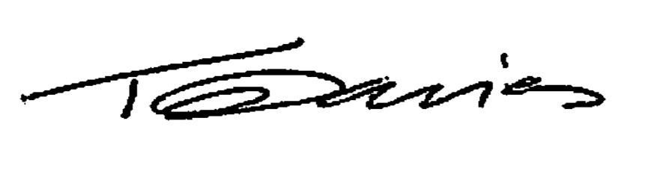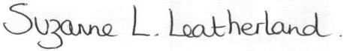
Dr Tim Davies Suzanne Leatherland
Consultant Lead for Screening and Immunisation Service Manager Immunisation
NHS England – Central Midlands Leicestershire Partnership NHS Trust

NOTES ON COMPLETING THE ONLINE CONSENT FORM
Visit: www.leicsandrutlandimms.co.uk/Forms/Flu
Enter and confirm your email address
Enter your school code: LE146621 and click find school. Your school name should appear.
Top tip: Ensure that the email addresses match and that there are no spaces or punctuation before or after the email address and school code.
PART 1: Patient Information and Contact Details
Please include your child’s NHS number, if available
If you are registered with a GP practice you will already have this number. It is a 10 digit number which is unique to every individual and can be found on their medical card. It can also be found on any letter from the NHS, any prescription and in every child’s red book – “my personal child health record”.
PART 2: Consent Declaration
Complete this to give consent to the flu vaccination.
PART 3: Medical History
Complete the questions regarding vaccination history and any support required during vaccination.
THIS FORM MUST ONLY BE COMPLETED BY SOMEONE WITH PARENTAL
RESPONSIBILITY. Guidance about parental responsibility can be found at: www.gov.uk/parentalrights-responsibilities
Sharing information: After the vaccination at school, a notification will be provided and the information will be added to your child’s NHS health record.
To translate the information on the NHS website into a different language visit: www.nhs.uk/accessibility/health-information-in-other-languages
Page 3 of 3
2020-1-A-v1.0

