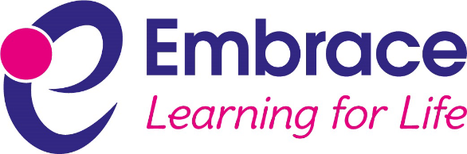

18 December 2020

Dear Parents/Carers
I am sorry to contact you at this time of the term, but feel compelled to do so following the government’s recent announcements around rapid testing in schools next term and the phased return for secondary schools.

You were informed by the government about these initiatives at the same time as schools and with the same small amount of detail. Like us, you will have many unanswered questions. We believe that further information will be made available to schools over the coming days, but of course schools are closed over the holiday period so it is impossible to react to these decisions in the way that we normally would.

What we do know about the staggered return to schools:
- All primary school children will return to school after the Christmas break. If your child attends one of our primary schools, please prepare to send them back to school as per original arrangements.
- Only Year 11 pupils, vulnerable children and the children of keyworkers will return to secondary school on Tuesday 5 January. Year 11 pupils must return as normal on this date and Brockington College will liaise with parents of vulnerable children and with those who are keyworkers. Some of this communication may not be possible until Monday 4 January.
- All other secondary children should study at home from Tuesday 5 January until Friday 8 January. Brockington College will liaise with parents of all other children regarding remote learning expectations and it is important that all children engage with this learning. Some of this communication may not be possible until Monday 4 January.
- All pupils will be back at school from Monday 11 January.

What we do know about rapid testing in schools:
- Schools will have access to rapid testing next term and can choose to implement rapid testing, but it is not compulsory for the school to do this or for parents (or 16 year olds) to give consent.
- Schools may choose to offer tests to members of staff on a weekly basis.
- Schools may choose to offer tests to pupil and members of staff who are close contacts with someone that has tested positive. Each individual testing negative will be able to say at school and will not be required to self-isolate.

We do not know the precise details of how the testing will be carried out at this stage and for this reason will not be offering this service at the very start of term. Our response will be to ensure that we are fully aware of the process before deciding on what we offer and when. If we go ahead, we will put procedures in place beforehand and we will communicate fully with members of staff and parents/carers, including to gain consent. We will of course need rapid testing kits and there is to date no information available on when, in what quantity and how these will be delivered to schools.

This initiative has the potential to improve current safety levels in schools and to help drive down levels of the virus. We do of course support the initiative. It is however extremely disappointing that this news has reached us all at this time and in this manner. We will as always react proportionately and do the best for our communities.

I hope that you are able to have an enjoyable family Christmas and thank you again for your ongoing support. I know how much the Embrace schools appreciate this.

Yours sincerely

Mr Chris Southall Trust Leader

